Assignment - 4

Student Name/ID Number: | Wildan Luqmanul Hakim
Academic Year: | 2022
Module Name: | Front End Web Development
Project Title: | Single Page Application
Submission Date: | May 4, 2022

Date:
Student signature:
I certify that the work submitted for this assignment is my own and research sources are fully acknowledged.
Learner declaration

Purpose of this project
Purpose of this project
To demonstrate your capabilities in the following areas:
- Plan a Website & Develop branding, wireframes, information architecture & storyboard.
- Develop a website using HTML, CSS & JavaScript.
- Develop jQuery Menus & Tabs
- Develop a Single Page Application
- Execute the test cases and validate the website meets the design requirements.
- Configure the virtual host and deploy the application
Submission Format
- Website screenshot in word document
- Source code
Project Brief & Guidance
Scenario:
Setup the Application (Download the source code) in Apache and get the screen capture of Modify the application to add a product detail page for each product (4 pages, 1 page for each product)
- Change the product price based on the currency selected.
- Create your own json file for currency conversion
- Call a Server-Side Script with product Id.
- Read the product page using the Server-Side Script.
- Display it in the main content area of the demo products page.
- Configure Apache to use Single IP Address (your local IP Address) to host www.<studentno>-1.com
www.<studentno>-2.com
Define the document root as below C:/vhosts/<studentno>-1 C:/vhosts/<studentno>-2

- Secure the host www.<studentno>-2.com using .htaccess and .htpassword
- Deploy the application and capture the screenshot as below

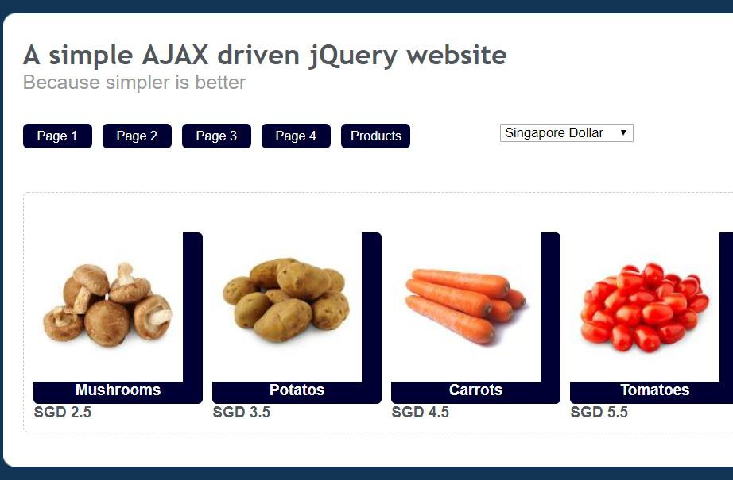
The website that you have developed needs to be tested by you and final sign-off should be
taken from ‘ABC Learning Center’ (Mentor) before hosting it on their web server.
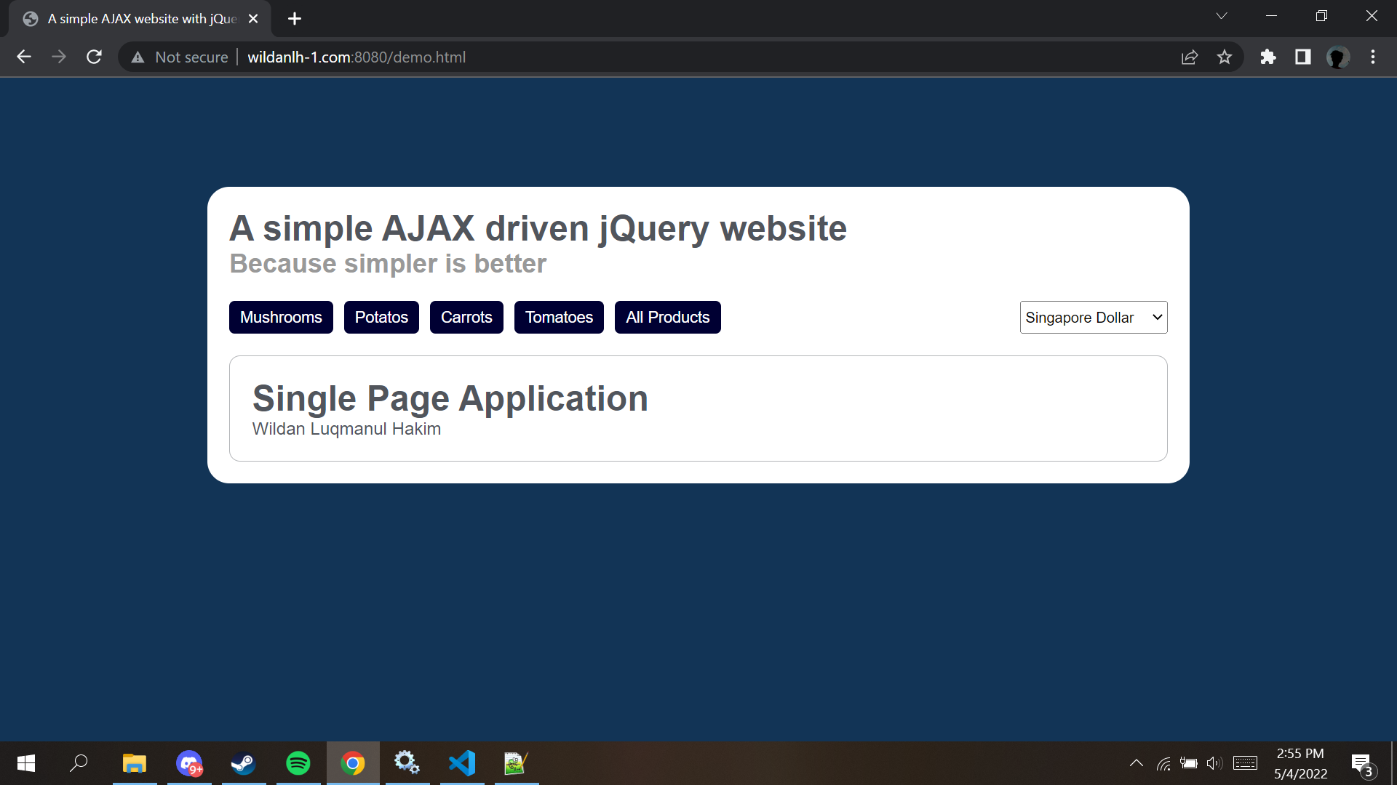
First Open The Website

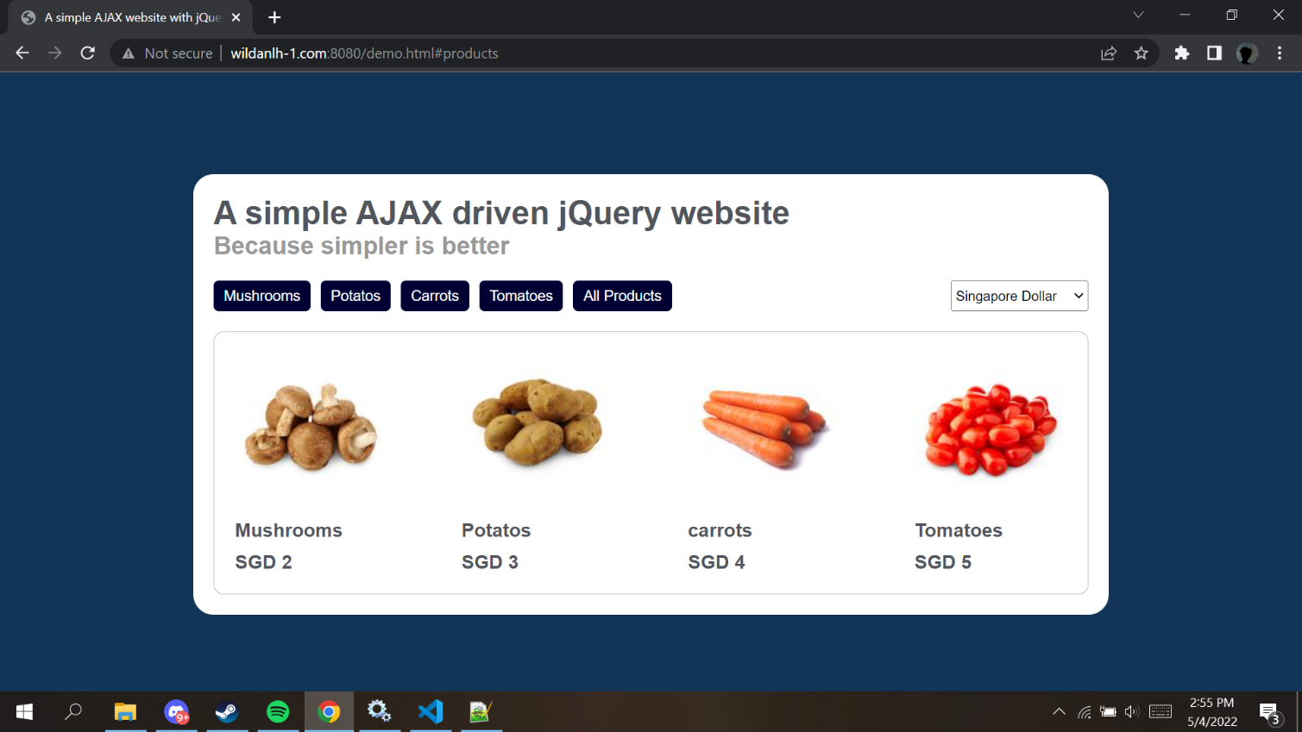
SGD Currency
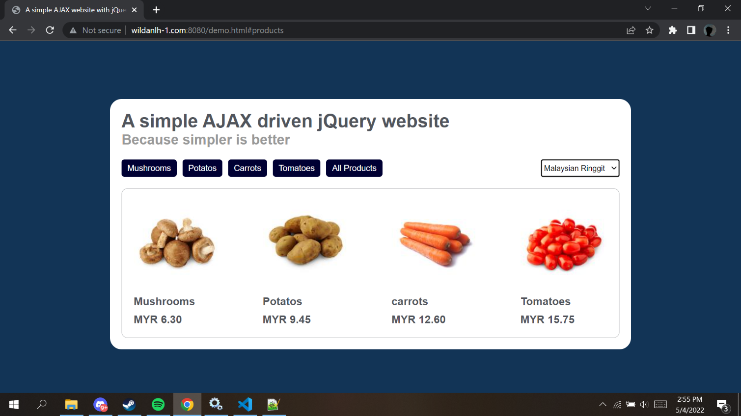
MYR Currency
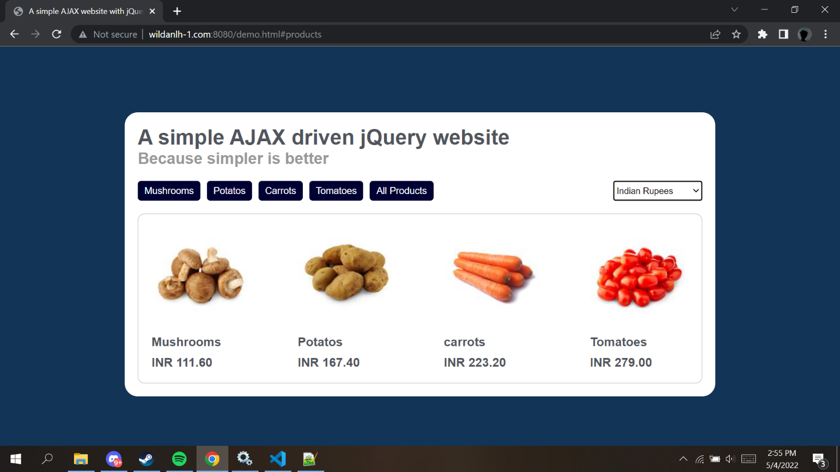
INR Currency
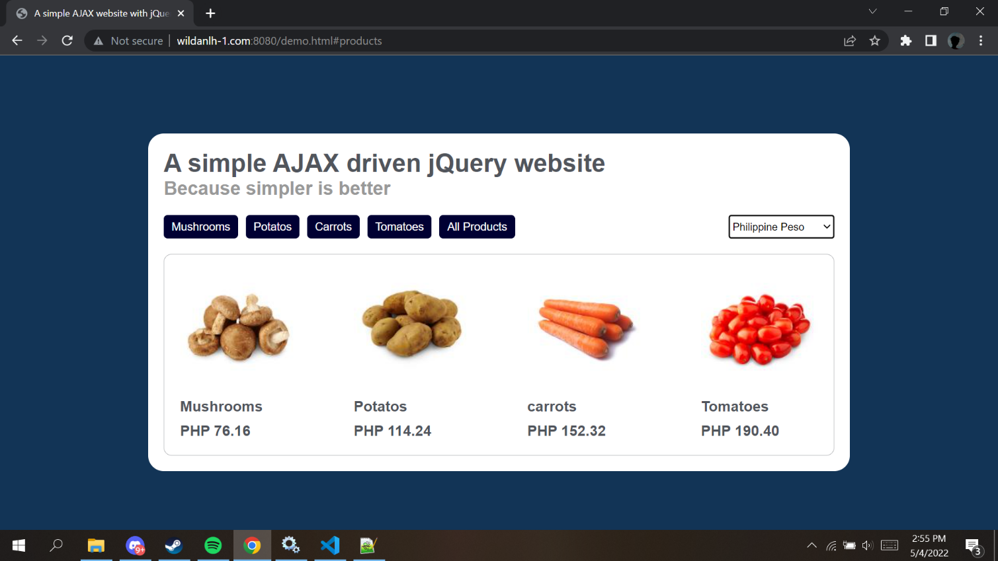
PHP Currency
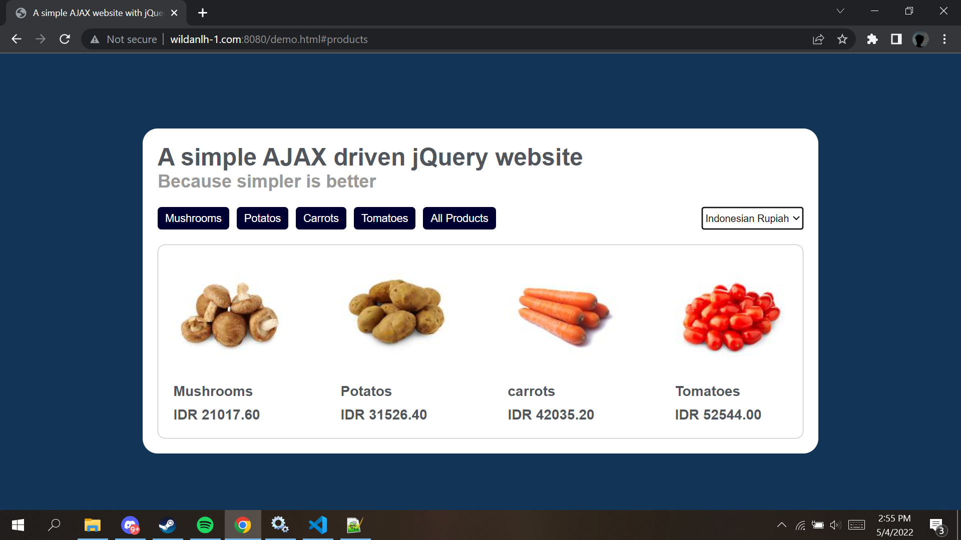
IDR Currency
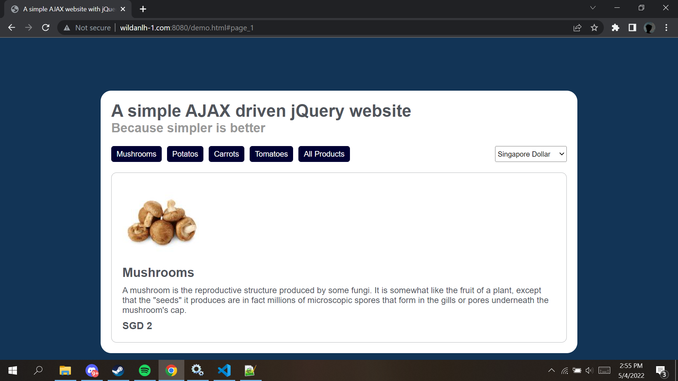
Mushrooms Page
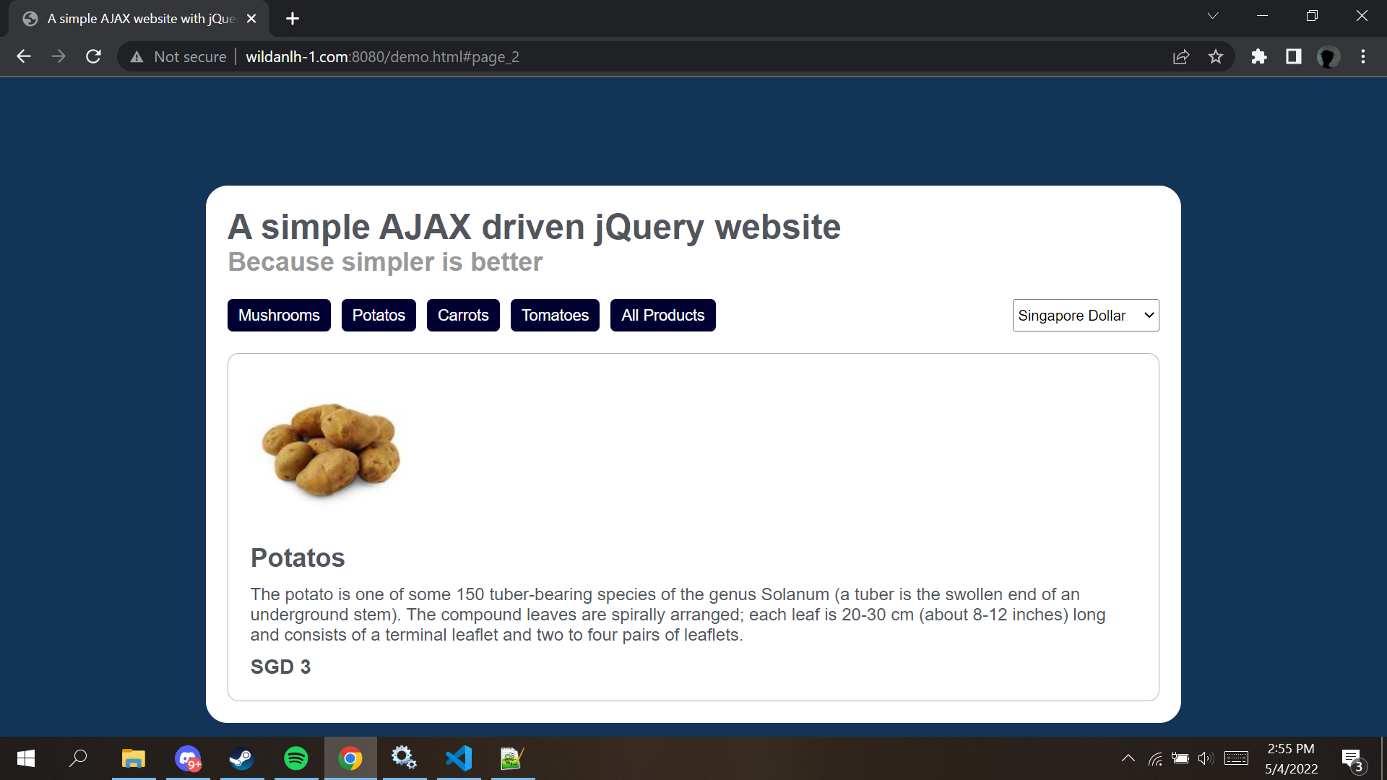
Potatos Page
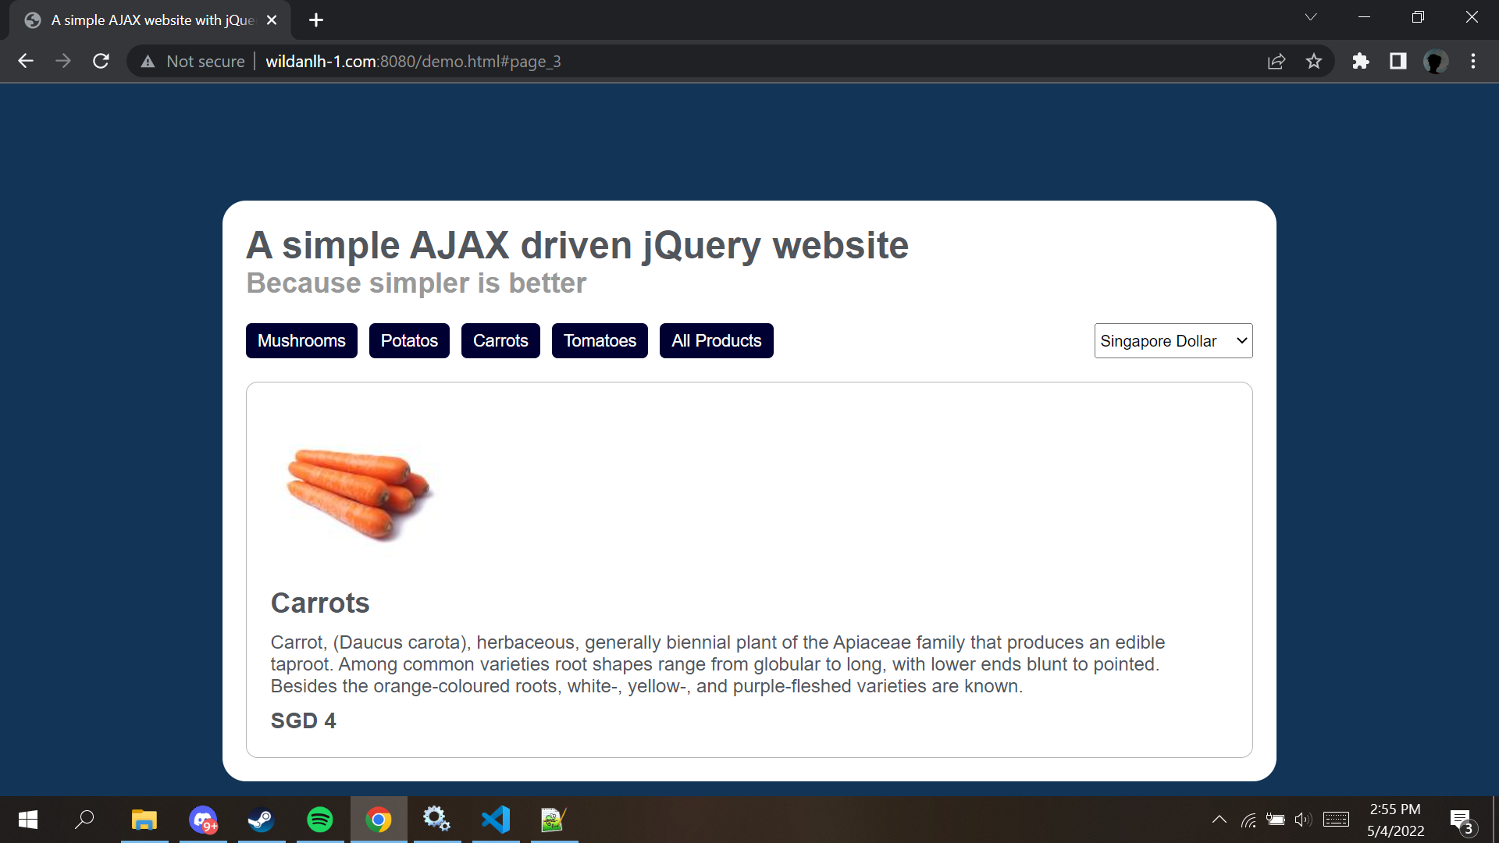
Carrots Page
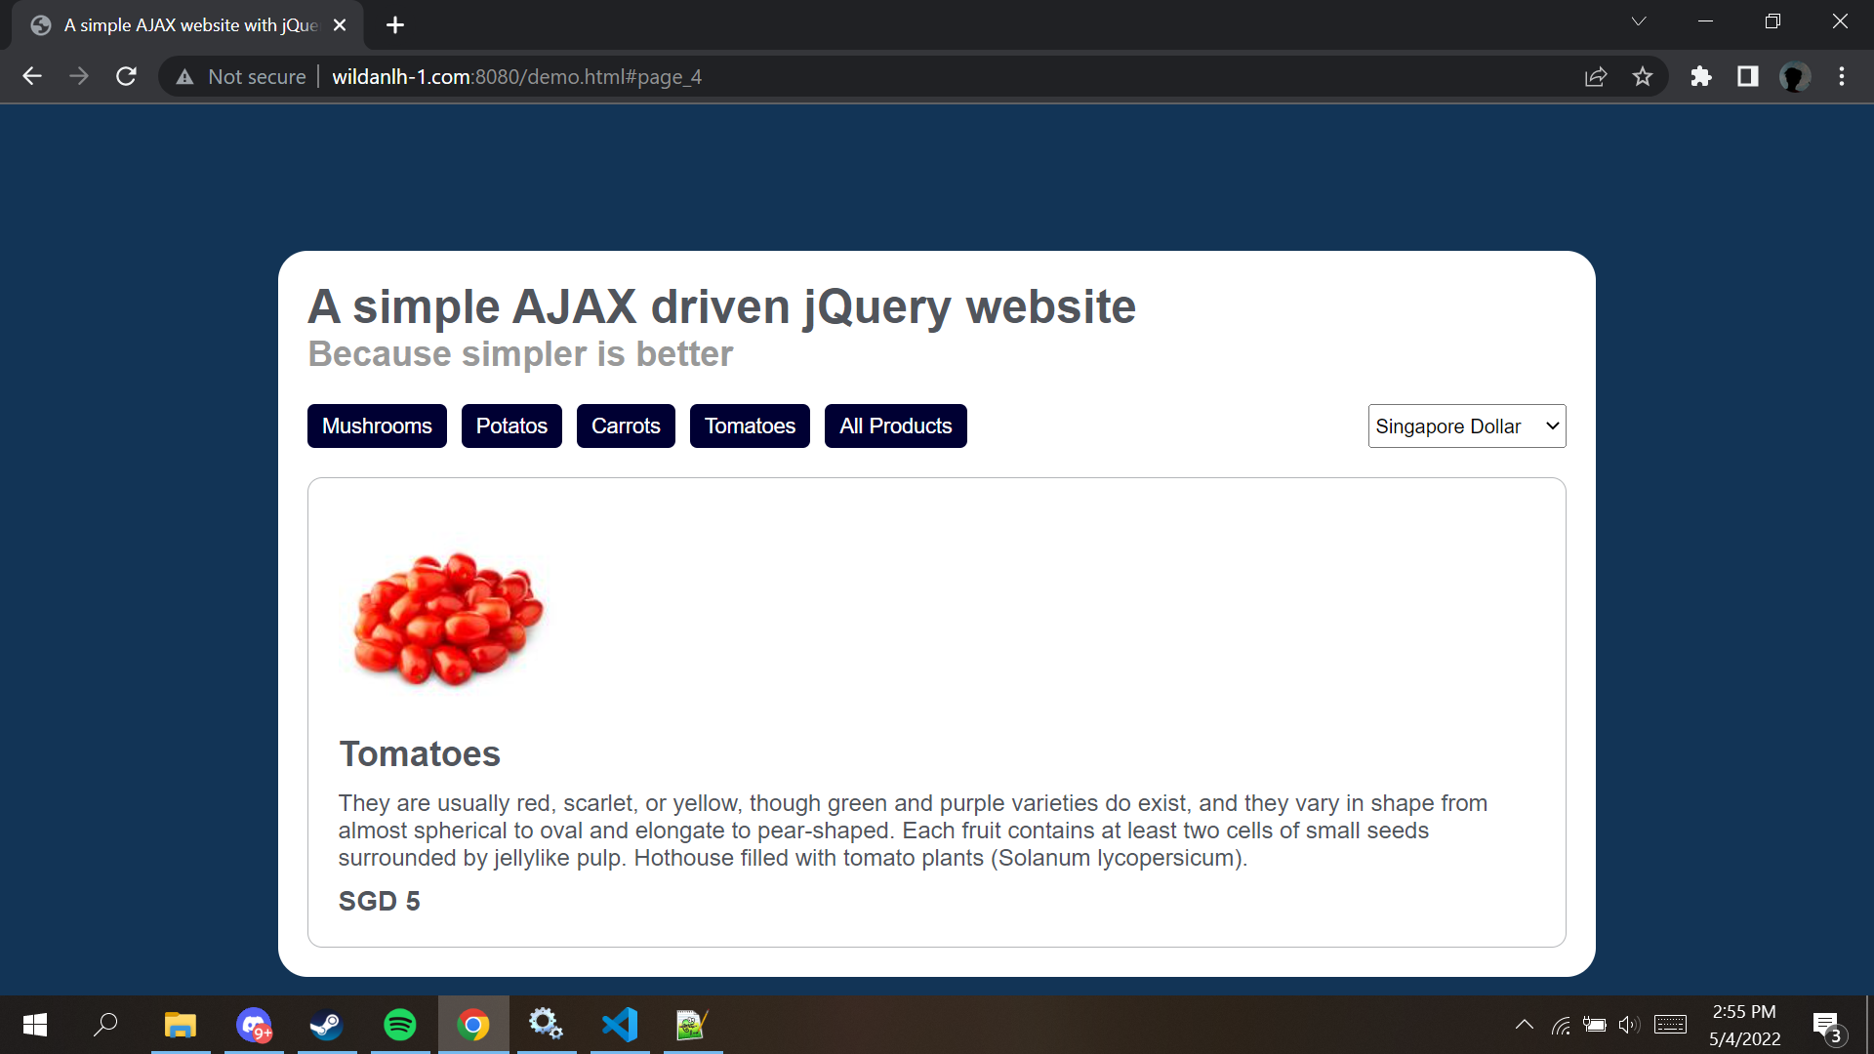
Tomatoes Page

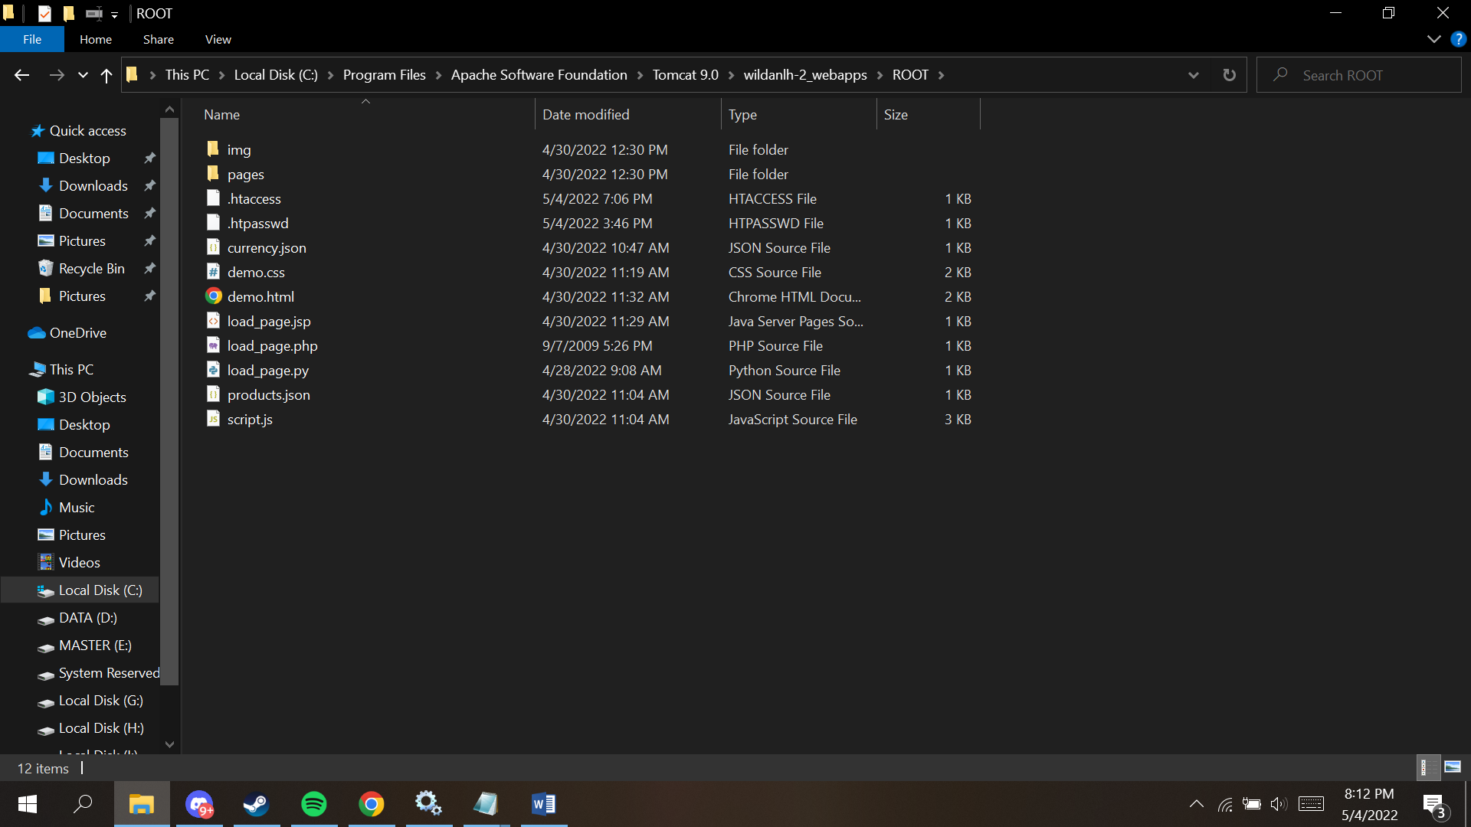
.htaccess & .htpasswd www.wildanlh-2.com
